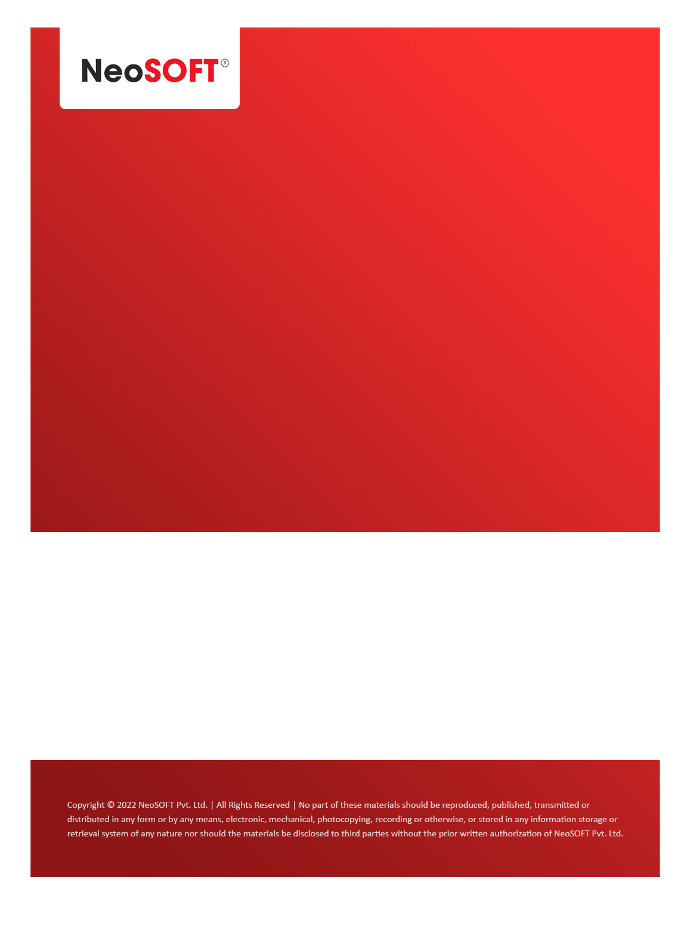`

**Eltizam MOM – Wireframes Review Meeting - II**

Eltizam

Client Name

NeoSOFT is a SEI-CMMI Level-5 Global IT Consulting & Software Solutions Provider

**April 12**, 2023

|  |  |
| --- | --- |
| **Meeting Date, Time, and Attendee Details** | |
| **Date** | 12th April 2023 |
| **Venue** | MS Teams |
| **Time** | 06.00 PM – 07.00 PM IST |
| **Meeting Type** | Wireframes review change discussion |
| **Internal Attendees** | * YallaReddy * Akshata Shinde |
| **Client Attendees** | * Karuna Pawar |
| **Presented By** | * Akshata Shinde |
| **MOM Prepared By** | * YallaReddy |

|  |  |
| --- | --- |
| **Details of Meeting** | |
| **Sr. No.** | **Description** |
| 1 | Akshata presented latest wireframes after doing review meting - I requested changes. |
| 2 | Got 2-3 minor suggestions from Karuna on latest wireframes & we will work on them & completes before tomorrow’s status call. |
| 3 |  |
| 4 |  |
| 5 |  |

|  |  |  |  |  |  |
| --- | --- | --- | --- | --- | --- |
| **Actionable** | | | | | |
| **Sr. No.** | **Action Item** | **Assigned to** | **Assigned Date** | **Expected Completion Date** | **Status** |
| 1 | Schedule call with Vinod & team tomorrow to share latest wireframes. | Akshata | 13th Apr |  |  |
|  |  |  |  |  |  |
|  |  |  |  |  |  |